**MongoDB Task**

1)Find all the topics and tasks which are thought in the month of October

db.Mentor.find({month:”Octomber”}).forEach(function(completed){print(“Task “ + completed.task , “Topics ” + completed.topic)})



**2) Find all the company drives which appeared between 15 oct-2020 and 31-oct-2020**

db.Company.find({arrived:{$gt:”ISO Date(15/10/2020)” , $lt:”ISO Date(31/10/2020)”}})

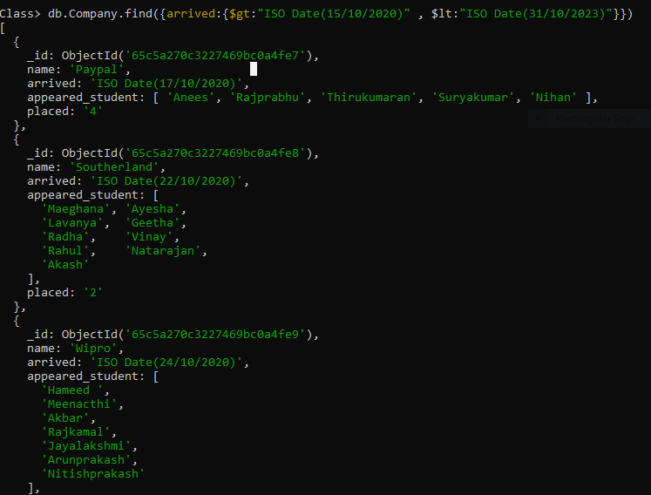

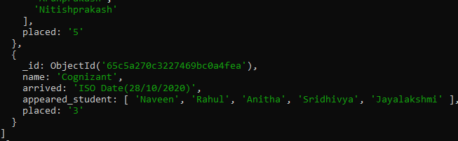

**3) Find all the company drives and students who are appeared for the placement.**

db.Company.find().forEach(function(stud){print(“Company Name ” + stud.name , “Student appeared” + stud.appeared_student)})

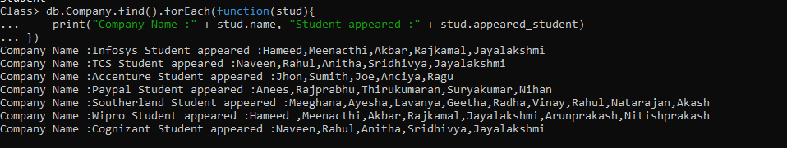

**4) Find the number of problems solved by the user in codekata**

db.Student.find().forEach(function(code){print(“Name :“ + code.name , “Codekata Count :” + code.codekata)})

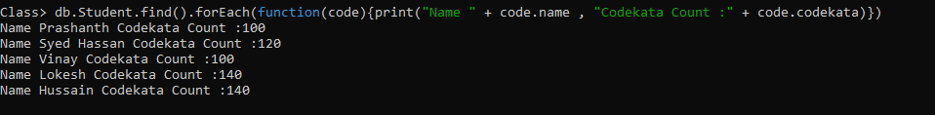

**5) Find all the mentors with who has the mentee's count more than 15**

db.Mentor.find({mentee:{$gt:”15”}}).forEach(function(mentor){print(“Name : “ + mentor.name)})



**6) Find the number of users who are absent and task is not submitted  between 15 oct-2020 and 31-oct-2020**

db.Mentor.find({date:{$gt:”15/10/2020”,$lt:”31/10/2020”}}).forEach(function(user){print(“Absent :” + user.absent , “Task Not Submitted :” +user.not_submitted)})

